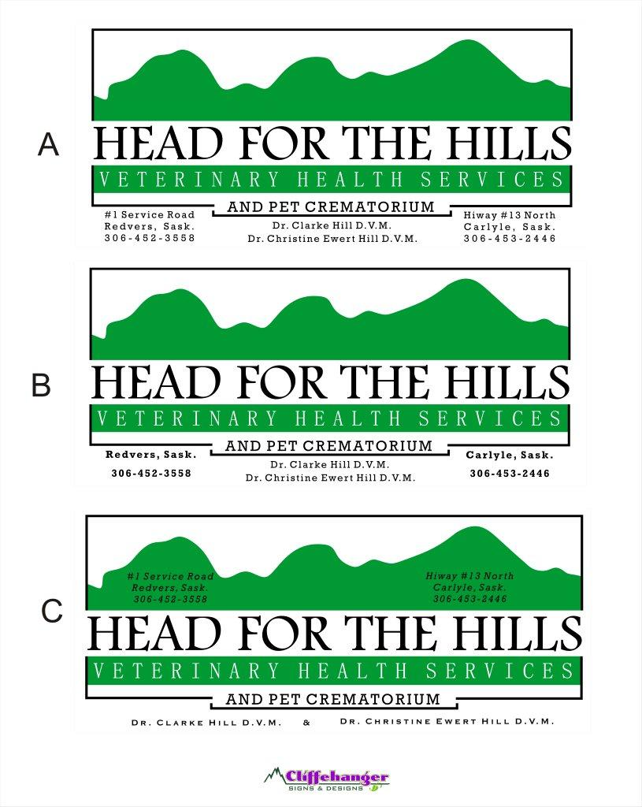

**Carlyle, SK**

**306-453-2446**

**Redvers, SK**

**306-452-3558**

**Kipling, SK**

**306-736-2516**

**Saturday May 14th, 2016**

Alida: 11:30am-12:30pm (Rink)

**Tuesday May 17th, 2016**

Lampman: 9:30-10:30am (Fire Hall)

Kisbey: 11:15-11:30am (Fire Hall)

Arcola: 12:00-12:30pm (Fire Hall)

Kenosee Lake: 1:30-1:45pm (Town Shop)

Whitebear: 2:00-2:15pm (Parking lot of #9 Food and Gas)

Manor: 3:00-3:30pm (Fire Hall)

**Wednesday May 18th, 2016**

Wauchope: 9:30-10:15am (Beside the Church)

Antler: 10:45-11:00am (East of Bar)

Bellegarde: 12:00-12:30pm (Beside the Credit Union)

Fertile: 1:00-1:30pm (Community Hall)

Storthoaks: 1:45-2:15pm (Community Hall)

Ryerson: 3:00-3:15pm (Old School)

Maryfield: 3:45-4:30pm (Fire Hall)

**No Appointment Necessary. We Accept Cash or Cheque.**

**We look forward to seeing you and your pet there!**

Rabies Clinic 2016